**26th April 2016**

**Encore: TV’s Rachel ‘Gearhead Diva’ De Barros has a Return Engagement at the YOKOHAMA LPGA Classic**

‘All Girls Garage’ star is back to give tyre tips clinics at YOKOHAMA’s booth during pro golf tournament

SANTA ANA, CA. – Gearhead Diva is back. Rachel De Barros, one of the stars of the Velocity Network’s All Girls Garage and host of GearheadDiva.com, will once again hold tyre clinics during the Yokohama Tire LPGA Classic in Prattville, Alabama, which runs May 5-8.

De Barros will hold two clinics per day on Saturday, 7th May and Sunday, 8th May at the YOKOHAMA booth. One lucky attendee per clinic will win a $50 gift card. The schedule for the 15-minute clinics is as follows:

* Saturday, May 7th: 11 a.m. & 2 p.m.
* Sunday, May 8th: 11 a.m. & 2 p.m.

“Rachel was really well received last year,” said Alan Holtschneider, Yokohama Tire Corporation´s director of marketing. “She brings an incredible array of DIY knowledge and automotive enthusiasm, and she totally connects with consumers. We’re glad to have her back.”

Among the tips De Barros will provide are: how to determine if you need new tyres, how to choose correct tyres and basic tyre maintenance.

“I’m a total tyre geek,” confessed De Barros, “and I love to help people learn how to get more from their tyres, improve their ride and save money. That’s what I’ll be doing again at the tyre tips clinics. It’ll be fun, yet informative. So many people sometimes forget to take care of their tyres, which are the only part of their car that actually touch the road.”

In addition to tyre clinics, De Barros will encourage visitors to race in the “Drive to Win” challenge, also taking place at the booth. Each day, the fastest time on the YOKOHAMA Gran Turismo 6 racing simulator will be awarded a gift certificate for a set of YOKOHAMA high performance, passenger or light truck tyres. All other participants will be entered in a raffle for daily prizes.

Yokohama Tire Corporation is the North American manufacturing and marketing arm of Tokyo, Japan-based The Yokohama Rubber Co., Ltd., a global manufacturing and sales company of premium tyres since 1917. Servicing an extensive sales network throughout the U.S., Yokohama Tire Corporation is a leader in technology and innovation. The company’s complete product line includes tyres for high-performance, light truck, passenger car, commercial truck and bus, and off-the-road mining and construction applications.

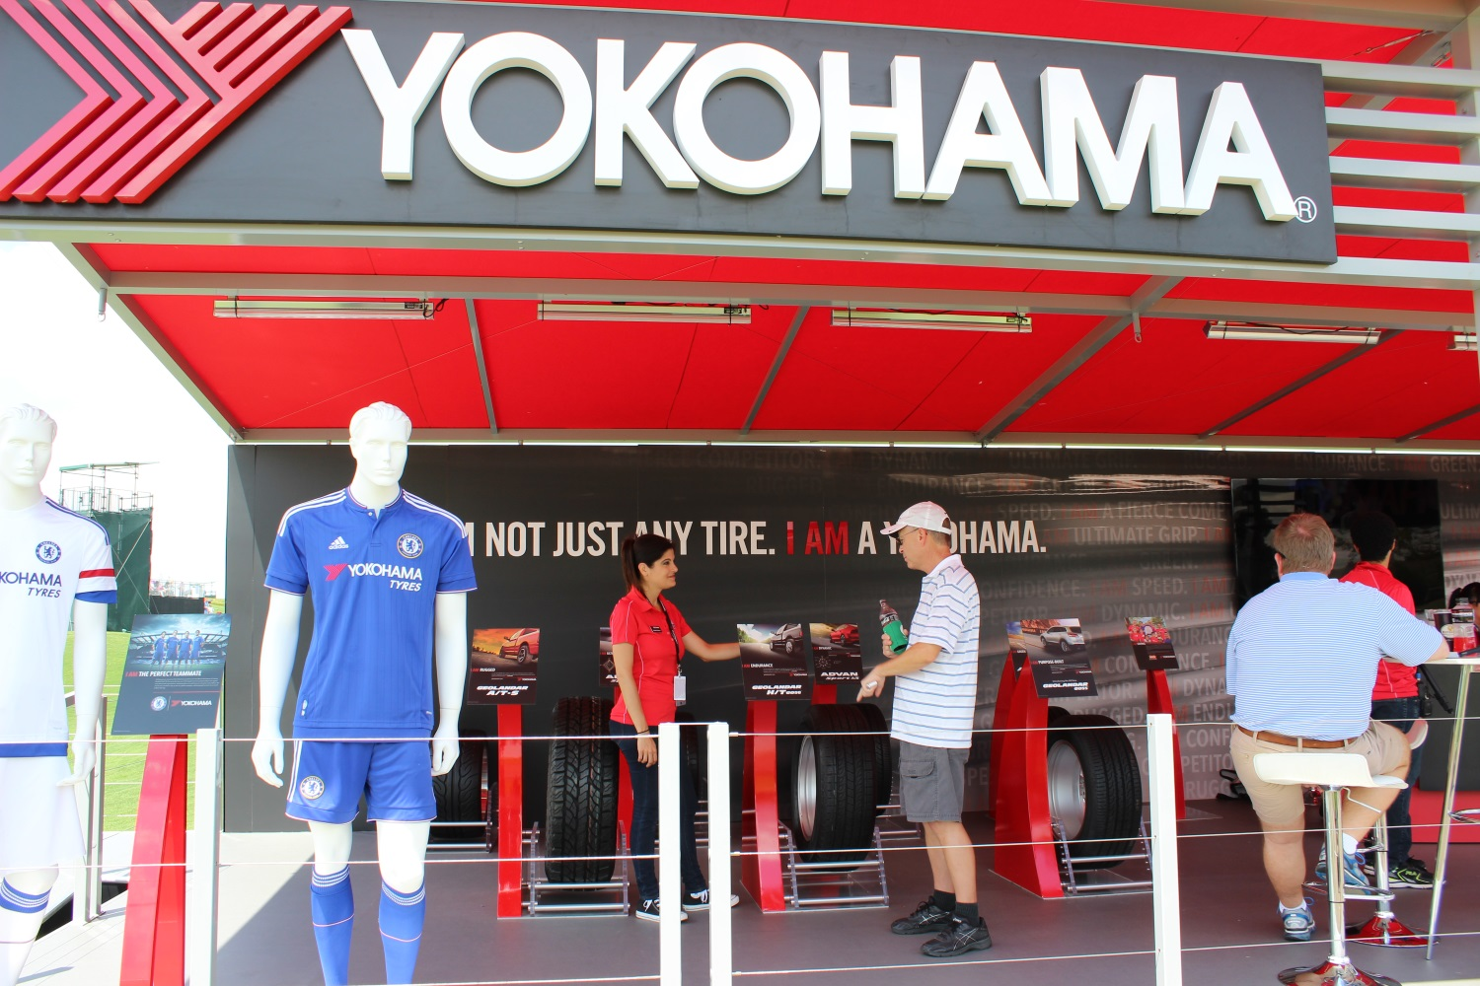

LPGA Yokohama Tyre Clinics, Gearhead Diva